## This is meant to be super simple and can just be “done” in spare time.

## You will make typos. This will lead to debugging. Which is how we learn,

This will teach how some api responses work. And some python exercises that are super simple. You can ignore anything after #### marks which are meant to be comments.

You need requests library. See below

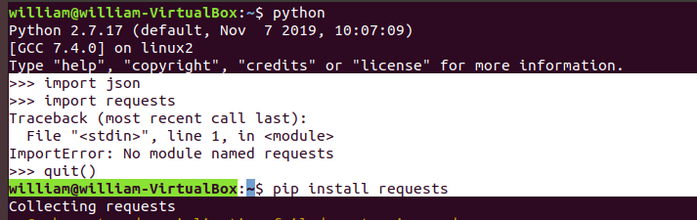

## Step 1: Deck of Cards API

This is super simple, clean and easy. You can do this from the interpreter to see issues in real time,

Python

Import requests

Import json

url = “<https://deckofcardsapi.com/api/deck/>” #### this is the base url

resp=requests.get(url+”new/”) ### this should not return any errors,

##### note we append “new/”to make a new deck

print(resp) #### this should show a 200

print(resp.text) ##### this should show the response body, you see the deck id,

#### we need to get the deck id so we can do things. It is in text, we need it in json.

deck=json.loads(resp.text)

decknumber=deck[“deck_id”]

print(decknumber)

draw2url=url+decknumber+”/draw/?count=2”

print(draw2url) ####### I keep doing this a debug.

cards=requests.get(draw2url) ############ get 2 cards from deck

print(cards) ######## print it, its in text

jsoncards=json.loads(cards.text) ######## load it into json

print(json.dumps(jsoncards, indent=2)) ###### print it pretty like